**Project Title**: Tic Tac Toe Game
By Cory Simmonsen

**1. Introduction**

The Tic Tac Toe Game is a Python-based implementation of the classic two-player strategy game. This project showcases several technical features, including player versus computer gameplay with AI, advanced algorithms like minimax with alpha-beta pruning, dynamic board sizing, and a text-based interface.

**2. Design and Implementation**

**Design**: The project follows an Object-Oriented Programming (OOP) approach and comprises three primary modules: `game_model.py`, `game_view.py`, and `main.py`.

- `game_model.py`: This module encapsulates the game's core data structures and logic. It defines classes for the game board, player, and game data. The board is represented as a 2D list, and it includes the logic for win or draw conditions.

- `game_view.py`: Responsible for the user interface and interaction, this module hosts the `TicTacToe` class. It manages rendering the game board, obtaining user input, and controlling the game flow.

- `main.py`: The entry point of the game initializes the necessary components and orchestrates the main game loop.

**Implementation**: The game boasts several noteworthy technical implementations:

- Player versus computer gameplay: Players can select their symbol (X or O) and decide whether they want to make the first move. The computer opponent employs a sophisticated minimax algorithm with alpha-beta pruning for intelligent decision-making.

- Variable board sizes: Players can choose from a range of board sizes, from the classic 3x3 grid to larger 6x6 grids, adding complexity and challenge.

- User-friendly interface: The game features clear instructions, guides players through symbol selection, and presents the game board visually.

**Modifications and Challenges**: Key challenges during implementation included optimizing the computer AI for larger board sizes. To address this, we fine-tuned the minimax algorithm and introduced alpha-beta pruning for enhanced performance. Codebase optimization focused on modularity and readability.

**Screenshots**:

- Initial Setup:
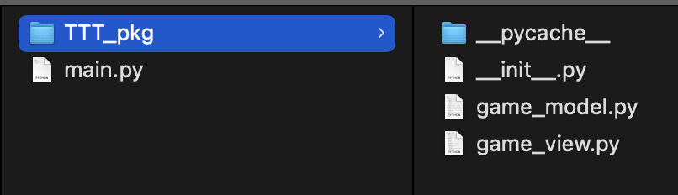
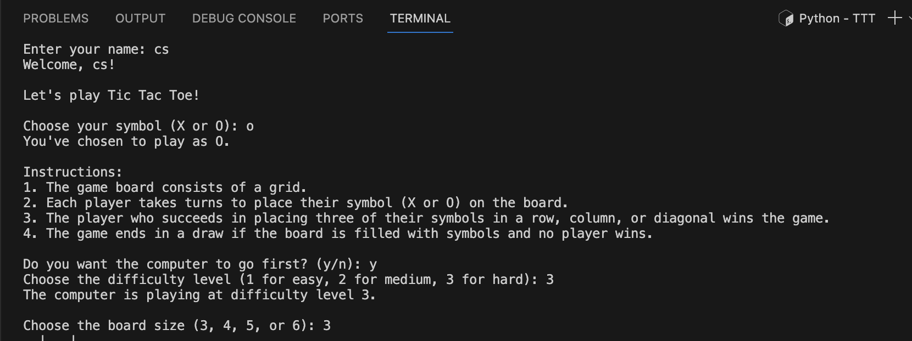

- Gameplay:
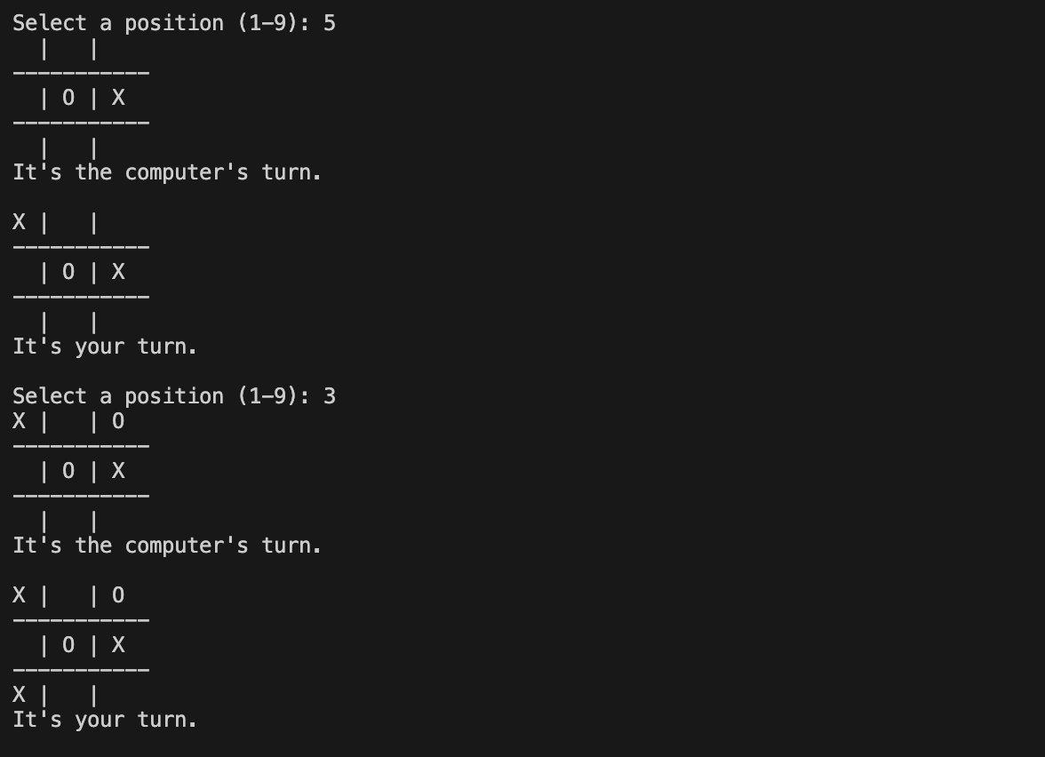
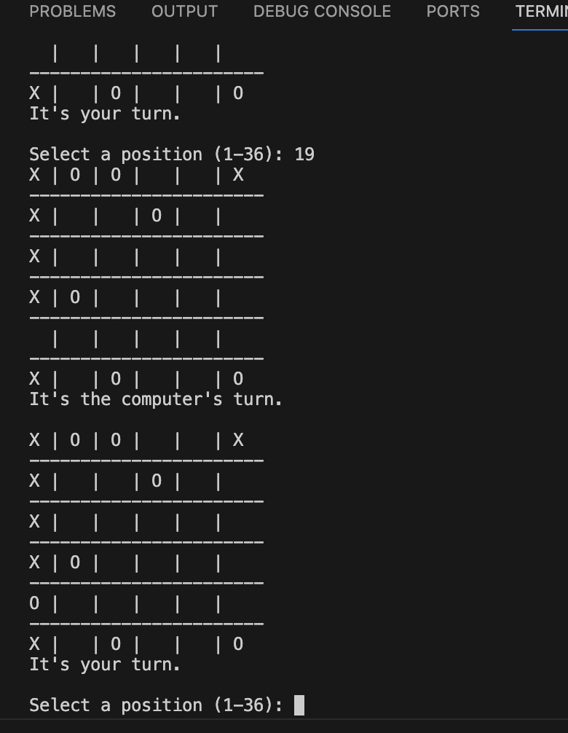
- Game Over:
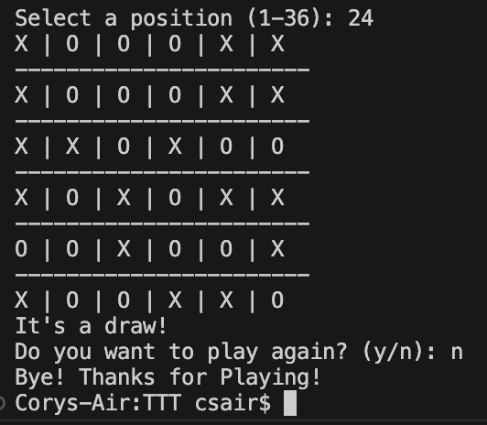
**3. Conclusions**

- **Technical Learning**: This project provided practical experience in AI implementation, advanced algorithm design, and user interface development. It allowed for skill development in problem-solving and coding efficiency.

- **Technical Highlights**: Notable features include adjustable board sizes, intelligent computer AI, and modular code architecture, promoting maintainability and extensibility.

- **Technical Shortcomings**: While the AI performs well, further optimization for larger boards remains a consideration. A graphical user interface could enhance user engagement.

- **Technical Hindsight**: In retrospect, exploring graphical libraries like Pygame could have been advantageous for a visually appealing interface. Future endeavors might involve exploring other open source libraries.

- **Technical Future**:

- **Graphical User Interface (GUI)**: Implementing a GUI using libraries like Pygame or tkinter would make the game more visually appealing and user-friendly, attracting a broader audience.

- **Multiplayer Mode**: Incorporate a multiplayer mode that allows two human players to compete against each other, either locally or over a network.

- **Online Play**: Extend the game to enable online multiplayer matches, offering a competitive experience with players from around the world.

- **AI Optimization**: Continue refining the AI's decision-making process, especially for larger board sizes, to maintain an optimal player experience.

- **Customization**: Allow players to customize game elements, such as board size, symbols, and AI difficulty levels, to cater to different preferences.

- **Statistics and Leaderboards**: Implement features to track player statistics and maintain leaderboards to encourage competition and engagement.

By investing some time to experiment, the Tic Tac Toe Game can evolve into a more comprehensive and engaging gaming experience, appealing to a wider audience of players and provide a platform for future enhancements.

